**GitFlow**

**git clone --recursive https://github.com/petervanderdoes/gitflow-avh.git**

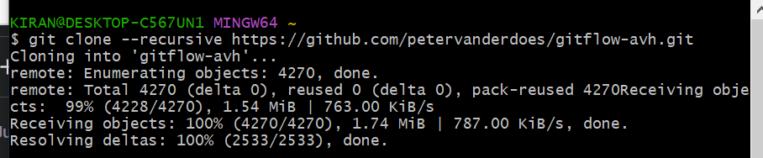

**cd gitflow-avh**

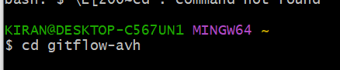

**git flow init –d**

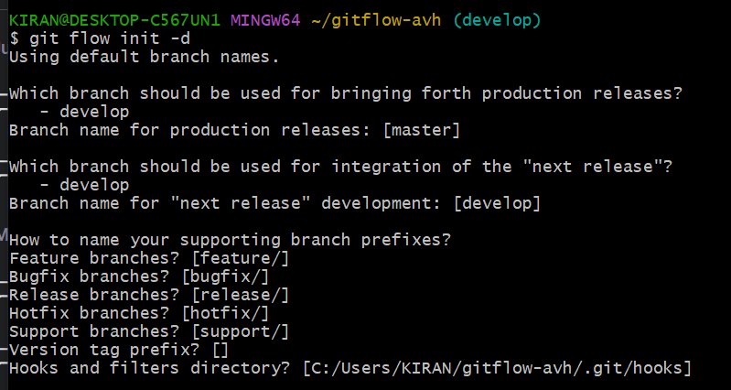

**git flow version**

